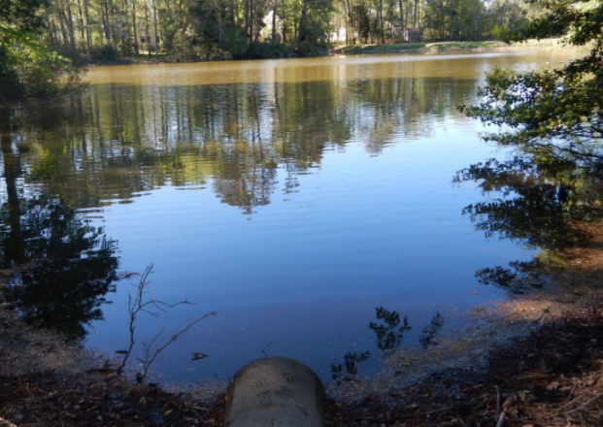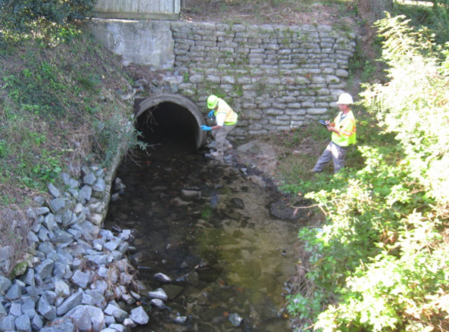

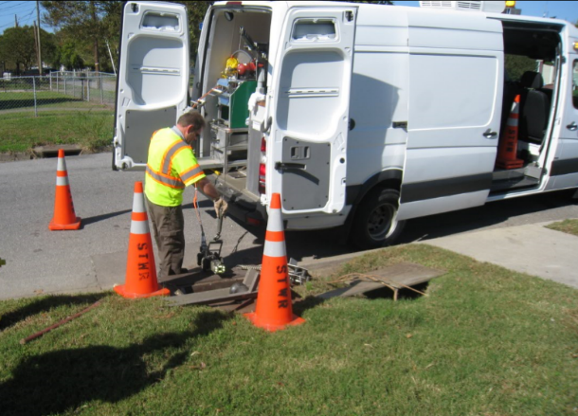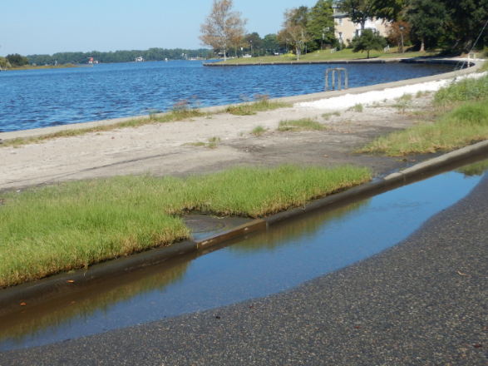

Hampton Roads Planning District Commission MS4 Communities

Illicit Discharge Detection and Elimination Field Guide for the Coastal Plain:
How to Identify and Quickly Report Pollution Problems

Funding: National Fish & Wildlife Foundation
Written by: Center for Watershed Protection

April 2017

1. INTRODUCTION 3
What is an Illicit Discharge? 3
Why Is It Important to Report Illicit Discharges? 3
What to Look for in the Course of Your Day 3
2. HOW TO USE THIS MANUAL 4
Intended Audience 4
Purpose 4
What to Report 4
3. COMMON POLLUTION PROBLEMS 5
Sediment Discharge 6
Waste Management 7
Yard Waste 8
Hazardous & Industrial Materials 9
Washing Activities 10
Sewage Discharges 11
Swimming Pool Discharges 11
Landscape Irrigation Water 12
Water Main Breaks 12
Accident Spills 13
4. ILLICIT DISCHARGE CHARACTERISTICS 14
Odor 14
Color 14
Turbidity 16
Floatables 17
5. IDDE WRITTEN PROCEDURES 19
Appendix A: Outfall Reconnaissance Inventory (ORI) Form 34
Appendix B: Representative IDDE Standard Operating Procedures 37
EXAMPLE Water Sampling Standard Operating Procedure 38
EXAMPLE Outfall Screening Standard Operating Procedure 42
EXAMPLE Illicit Discharge Elimination Verification Standard Operating Procedure 47
Appendix C: Framework for Chemical Fingerprint Library 50

1. INTRODUCTION

What is an Illicit Discharge?
An illicit discharge is flow to a municipal separate storm sewer system conveyance or natural water body during dry weather conditions that contains pollutants and/or pathogens. A dry weather flow without pollutants or pathogens (e.g. groundwater), is simply a discharge.

Why Is It Important to Report Illicit Discharges?
The primary reasons for noting and reporting illicit discharges are:
- They contaminate water resources;
- They may threaten public health and/or the ability of the public to enjoy water resources;
- They are regulated under the jurisdiction’s Municipal Separate Storm Sewer System (MS4) permit and must be removed when detected. This permit applies to activities within the City/County, but is administered by the Virginia Department of Environmental Quality (DEQ) as part of the Clean Water Act.

What to Look for in the Course of Your Day
Many illicit discharges can be detected through visual assessments and simply paying attention to what’s going on around you during routine activities. This guide is intended to help you find, track, and report illicit discharges, thereby helping the City/County meet permit requirements. In general, what to look for in the field during the course of the day includes:
- Unusual odors, colors, or conditions in surface water, storm drain outfalls or inlets
- Cloudy or murky water
- Floatables, such as toilet paper, suds, or excessive trash
- Unnatural (excessive or dead) vegetation near an outfall pipe
- Odd deposits or stains on an outfall pipe
- Leaks, spills, or dumping of damaging fluids and/or materials
- Staining or discoloration around dumpsters, loading docks, and inlets

2. HOW TO USE THIS MANUAL

Intended Audience
This manual is intended to be used by City/County staff whose job necessitates frequent field or site visits, as well as staff responsible for administering the MS4 Permit. This may include staff from Public Works, Roads, Utilities, Erosion and Sediment Control Inspectors, Stormwater Inspectors, and others.

Purpose
The purpose of this manual is to assist field and program staff with proper identification, reporting, and resolution of pollution problems.

This manual is divided into several sections, described briefly below:

Common Pollution Problems – Describes common pollution problems that may be encountered during standard work days and routine activities. Problems are listed from those more likely to be encountered to less likely.
Illicit Discharge Characteristics – Describes characteristics and severity of various illicit discharge sources. This may be used to characterize pollution problems for reporting purposes or may be used for prioritization purposes during outfall inspections.
IDDE Written Procedures – Outlines procedures for illicit discharge screening, detection, tracking, and reporting, as required by the MS4 Permit.
Appendices – Contains field and laboratory forms, and other materials that are helpful for program documentation.

What to Report
Any flow occurring after 2 to 3 days of dry weather should be assessed according to the characteristics described in this guide. The flow may be present in an outfall, manhole, storm drain inlet, street or in any manner draining to the City/County’s storm sewer system. Any potential problems should be reported AS SOON AS POSSIBLE to City/County Stormwater Staff. NOTE: Especially in Hampton Roads, any such flow may be comingled with tidal water. However, be aware that contaminants may still be present, so the testing procedures still apply (with some potential modifications).

WHAT TO REPORT:
- Location of problem
- Time that problem was found
- Odor, color, turbidity, and floatables
- One or more digital photos to document the condition, if possible
- Any other relevant or pertinent information

TO WHOM TO REPORT:
- Stormwater Compliance Inspector, 757-XXX-XXXX, email

3. COMMON POLLUTION PROBLEMS

Illicit discharges are considered “illicit” because storm sewer systems, unlike sanitary sewer systems, are not designed to accept, treat, or discharge non-stormwater wastes. There are two primary categories of illicit discharges, as follows:

- TRANSIENT – Short in duration, lasting only a short time and then disappearing. Examples include:
      - Materials that have been dumped into a storm drain (catch basin) or drainage way, and
      - A floor drain that is connected to the storm sewer.

- CONTINUOUS – Continuing without changing, stopping, or being interrupted. Examples include:
      - Sanitary wastewater piping that is cross-connected from a building or sanitary sewer line to the storm sewer, and
      - An industrial operational discharge that is not permitted.

The following non-stormwater discharges are authorized unless the State Water Control Board or the permittee determines the discharge to be a significant source of pollutants to surface waters:
- Water line flushing;
- Landscape irrigation;
- Diverted stream flows;
- Rising ground waters;
- Uncontaminated ground water infiltration (as defined at 40 CFR Part 35.2005(20));
- Uncontaminated pumped ground water;
- Discharges from potable water sources;
- Foundation drains;
- Air conditioning condensation;
- Irrigation water;
- Springs;
- Water from crawl space pumps;
- Footing drains;
- Lawn watering;
- Individual residential car washing;
- Flows from riparian habitats and wetlands;
- Dechlorinated swimming pool discharges;
- Street wash water;
- Discharges or flows from firefighting activities; and
- Other activities generating discharges identified by the Department as not requiring VPDES
authorization.

Below you will find some common pollution problems and what you should do if you encounter them. For all cases in the “moderate” or “high” severity categories, note the location, take photos, and contact the Stormwater Compliance Inspector at 757-XXX-XXXX, email.

Sediment Discharge
Sediment or dirt should stay contained in a construction site and should not be on the streets where it can enter storm drains (Figure 1). Sediment problems are most likely to occur during or after rain, but may also occur if a site is being dewatered or if equipment is being washed down. Note that the source may be a regulated or un-regulated construction activity under the City/County’s erosion and sediment control ordinance and/or Construction General Permit.

- Where to look: Streams, storm drains, ditches, concrete curb.
- What to look for: Brown/orange, turbid water, usually with no unusual odor.

Figure 1. Sediment Discharge (Examples)
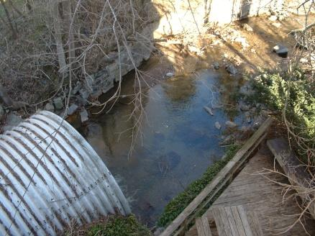  Low Severity Sediment Discharge | 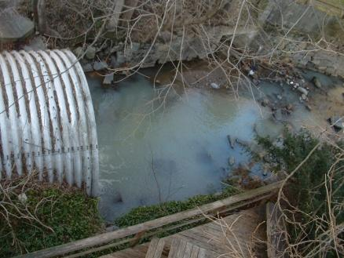  Moderate Severity Sediment Discharge | 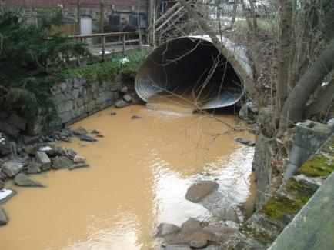  Severe Severity Sediment Discharge

Sediment discharges usually originate on the landscape and look like the examples shown in Figure 2.

Figure 2. Typical Sediment Discharge Sources
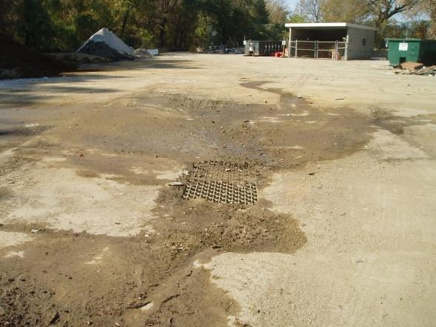  Unprotected storm drain inlet | 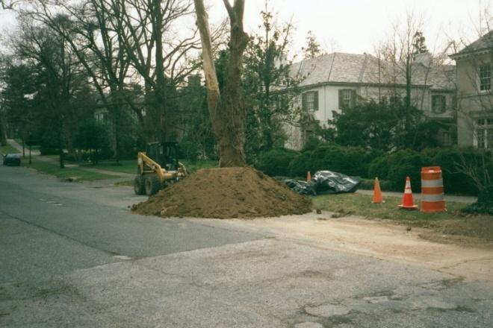  Soil piled on the street
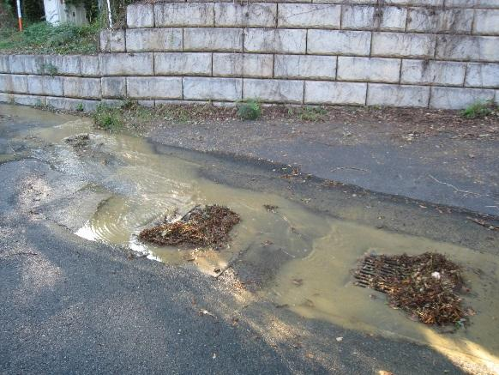  Construction site runoff | 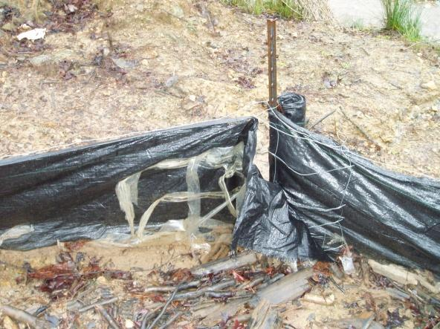  Failing silt fence

Waste Management
Trash and dumping areas are often found in vacant or infrequently visited parts of commercial and residential areas. Trash attracts rodents, can wash into the storm drains and ditches, and signals to others that it is acceptable to dump in the area. Improper dumpster and grease container management can also result in pollution that can wash into the storm drains and streams (Figure 3).

- Where to look: Behind restaurants, vacant buildings or homes, and/or dead end roads. Areas that people do not frequent such as near train tracks, behind buildings, and vacant lots.
- What to look for: Poorly managed grease containers and dumpsters, mattresses, furniture, tires, toys, food and drink containers, cigarettes, etc.

Figure 3. Trash / Dumping
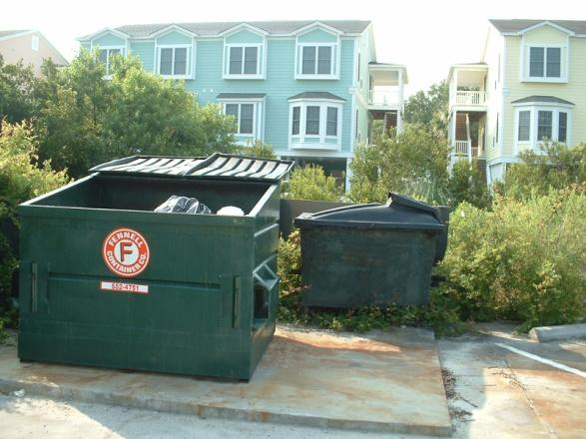  Low Severity Waste Management – Open dumspter with visible staining | 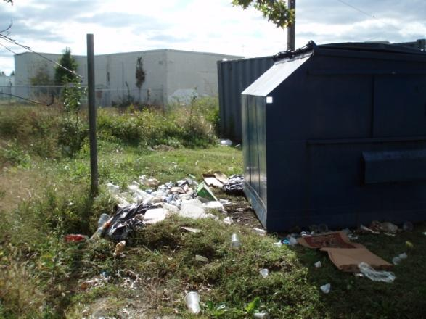  Moderate Severity Waste Management – Poorly managed dumpster and/or dumping
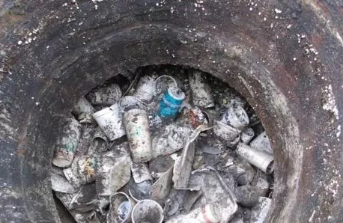  High Severity Waste Management –  Trash clogging storm drain manhole. | 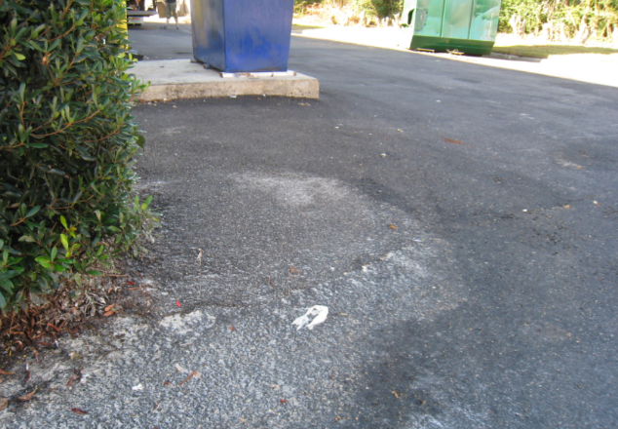  High Severity Waste Management –  Grease accumulation on lot draining to storm drain

Yard Waste
Yard waste is usually piles of leaves, mulch, branches, or other residential waste (Figure 4). When yard waste is exposed to rain and weather, it can wash away in large quantities and damage the environment. These excessive piles of yard waste are often found on the street, behind homes near streams, in riparian buffers, and in ditches. Yard waste can clog storm drain systems and choke streams.

- Where to look: Streets and sidewalks near homes. Ditches and streams near homes.
- What to look for: Piles of leaves, mulch, grass clippings, tree cuttings, sediment, trash, etc. Decomposed leaves create an “oily” multi-color sheen that breaks up when stirred with stick

Figure 4. Yard Waste
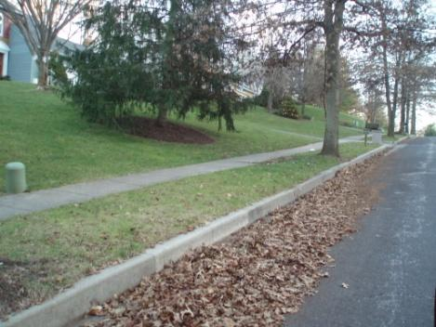Low Severity Yard Waste Management – Leaves accumulating in street gutter | 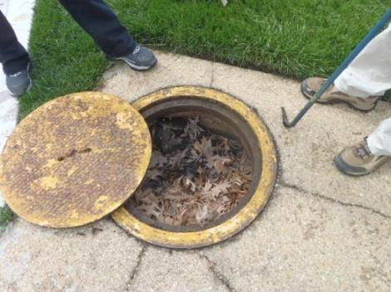  Moderate Severity Yard Waste Management –  Clogged storm drain | 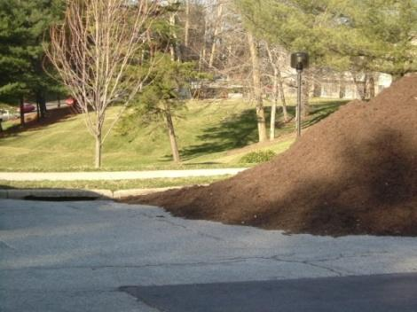  High Severity Yard Waste Management –  Pile of mulch in street next to storm drain

Chemicals
Many household and industrial products can contain chemicals that can be dangerous or potentially harmful to our health or the environment if not stored or discarded properly. These chemicals can be liquids, solids, gases, or sludge. Examples include household wastes such as paint and fertilizer; discarded commercial products, like cleaning fluids or pesticides; or the industrial by-products of manufacturing processes such as cooling tower water and concrete washout (Figure 5).

- Where to look: Automobile, construction site, and other commercial or residential businesses.
- What to look for: Paint, oil, automobile parts, fuel, construction material, chemical containers. Chemical/solvent odor.

Figure 5. Chemicals
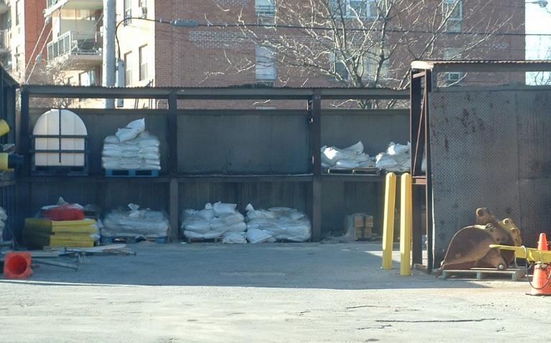  Low Severity Chemicals Management –  Miscellaneous waste stored outside, some under cover. | 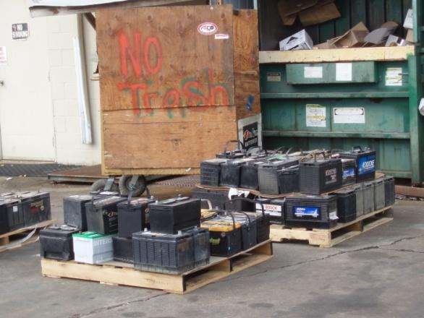  Moderate Severity Chemicals Management –  Batteries outside without cover, on pallets
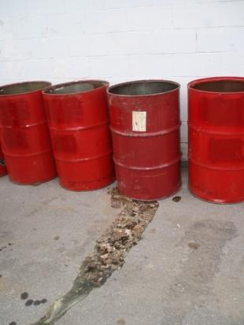  High Severity Chemicals Managemen –  Uncovered, unlabeled leaking barrels | 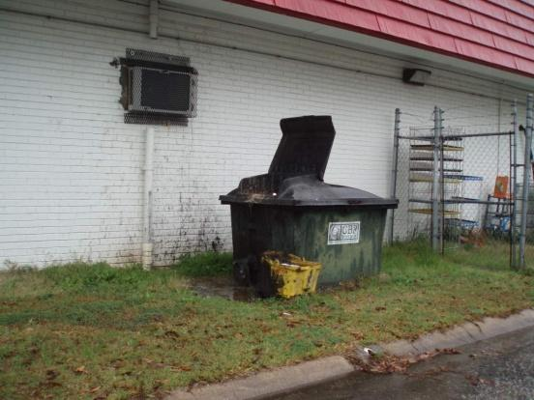  High Severity Chemicals Managemen –  Used oil container open with spills

Washing Activities
Outdoor washing may or may not be problematic. For example, hosing off a sidewalk or driveway or individual residential car may not generate significant flows or pollutant loads. These examples are not problematic unless done on an ongoing or chronic basis close to a waterway or storm drain. However, washing fueling areas, and power washing construction equipment in parking lots can generate significant flows or pollutant loads and are therefore problematic. Residential homeowner car washing and lawn watering are generally allowed activities, unless deemed to be “significant contributors of pollutants to the small MS4” (see authorized list of discharges at the beginning of this manual). Wash water dumping and vehicle washing at commercial establishments is not acceptable. Some examples are shown in Figure 6.

- Where to look: Car washes, car dealerships and rental companies, fire stations, fleet maintenance areas, and parking lots with mobile car washes.
- What to look for: Suds; sweet, fruity, detergent, or chlorine smells.

Figure 6. Building power washing and outdoor vehicle washing
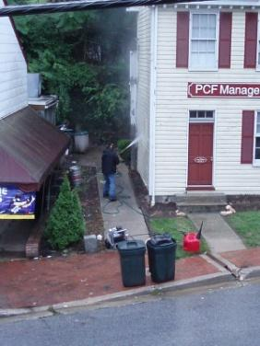  Low Severity Washing – Individual power washing building side without soap | 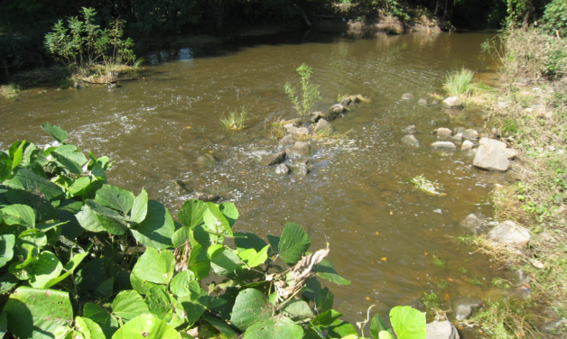  Moderate Severity – Suds persisting below outfall | 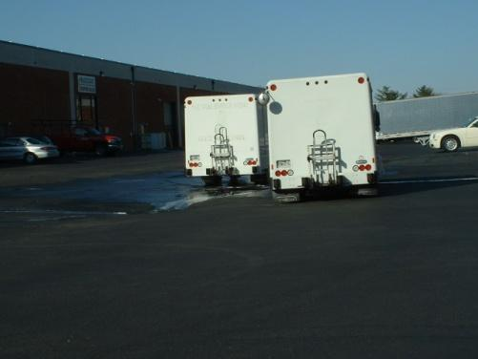  High Severity – Fleet vehicle washing next to storm drain

Sewage Discharges
Sanitary sewage can enter the storm drain and streams through cracks in sewer pipes, a failing septic system, straight pipes, and/or where a sewer pipe is improperly connected to a stormwater pipe. A transient discharge of sewage can also occur when sanitary sewer pipes overflow out of manholes (usually from a blockage or too much rain). Field crews may see any of these sources of discharges during routine activities. Some examples are shown in Figure 7.

- Where to look: In storm drains, near sewer manholes, in streams, exposed sewer pipes.
- What to look for: Sewage smells, gray water, toilet paper, scum in or below pipes.

Figure 7. Sanitary sewage discharge sources
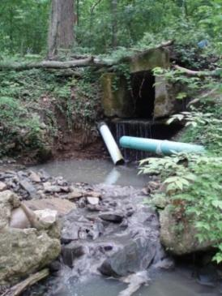  Sanitary pipe break | 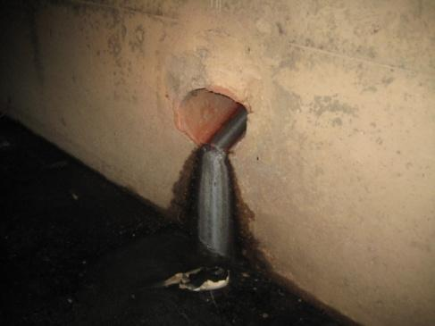  Illicit sewage connection | 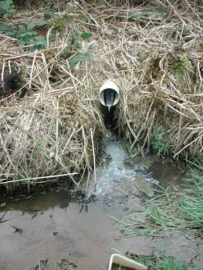  Sanitary straight pipe
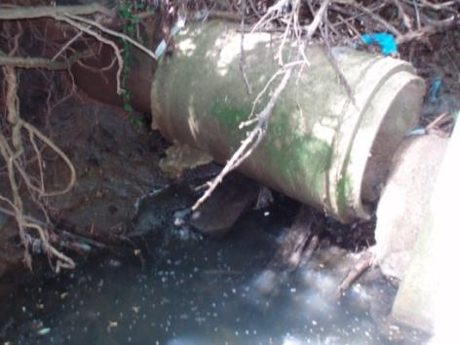  Illicit connection, downstream of source | 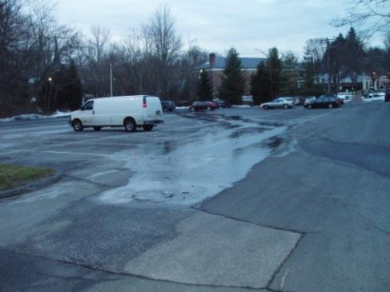  Surcharging sanitary manhole in parking lot

Swimming Pool Discharges
Chlorinated pool water being drained into a street or storm drain is considered an illicit discharge (Figure 8), while dechlorinated discharges generally are not (9VAC25-870-400 D 2 c 3).

- Where to look: Storm drain pipes, streets, driveways, yards.
- What to look for: Clear water with chlorine odor.

Figure 8. Suspect pool discharge
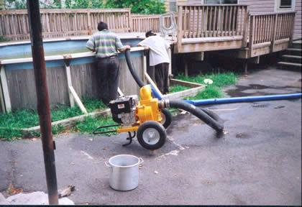

Landscape Irrigation Water
Landscape irrigation water can potentially carry excess nutrients and chemicals if it is coming from a highly fertilized area (Figure 9). In order to be considered an illicit discharge, irrigation water must be deemed by the MS4 to be a “significant contributor of pollutants to the small MS4” (9VAC25-870-400 D 2 c 3), which likely means that the issue is chronic and is leading to exceedances of one or more indicator thresholds (see Section 5, IDDE Procedures). Residential irrigation water is generally not a concern and does not need to be reported.

- Where to look: Nurseries, home improvement and garden supply stores, properties with highly manicured landscaping.
- What to look for: Clear water with chlorine or fertilizer smell; algae growth in path of water.

Figure 9. Suspect irrigation discharge
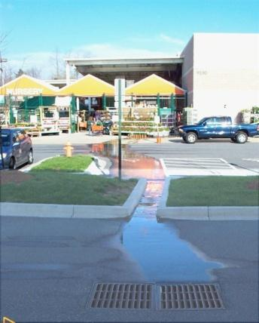
Irrigation water entering the storm drain system from a retail establishment

Water Main Breaks
Potable water leaking into the storm drain system is generally not considered to be a significant illicit discharge. However, water main breaks (Figure 10) can damage infrastructure, waste treated drinking water supplies, threaten public safety, and harm streams if breaks generate excessively high and erosive flows that contribute sediment to local waterways. In addition, the Chesapeake Bay expert panel on “Nutrient Discharges from Grey Infrastructure” considers “drinking water transmission losses” to be a source of nutrients that communities can potentially take credit for if leaks are fixed (Schueler et al., 2014). Water main issues may also be detected by the chlorine scent – if you smell a strong chlorine scent, this should be reported to the City/County water utility.

- Where to look: Streets, sidewalks, parking lots.
- What to look for: Clear water seeping or spewing out of pavement or storm drain.

Figure 10. Water main break
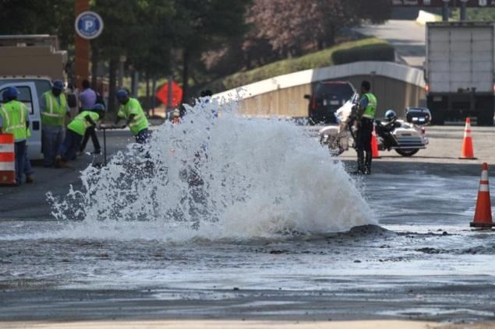

Accident Spills
Accident spills can enter ditches, storm drains, streams and rivers (Figure 11). Highway and road spills, particularly those involving hazardous waste, should be reported to 911. First responders will likely be the first personnel on-site, but the Stormwater Compliance Inspector may be of assistance in cases where spill response is needed.

Figure 11. Accident spills
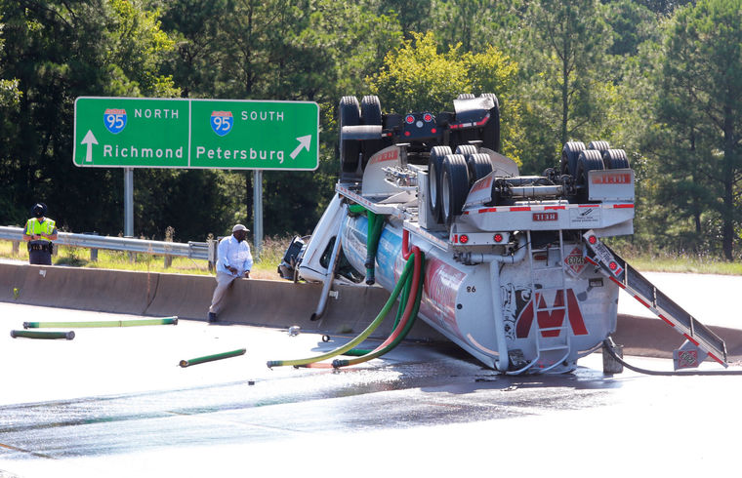
Accidental spills can be significant sources of pollution to the storm drain system

4. ILLICIT DISCHARGE CHARACTERISTICS

Illicit discharges have certain characteristics that are important to note when developing a report or conducting outfall inspections or dry weather screenings. These characteristics include odor, color, turbidity, and floatables, which are described in more detail here.

Odor
Determine if there is an odor coming from the suspected illicit discharge. Potential odors that you may encounter are:

- Musty
- Sewage
- Rotten eggs (sulfide)
- Gas or oil
- Sharp, pungent (chemicals)
- Rancid/sour
- Chlorine
- Sweet/fruity

The field crew should reach consensus as to whether an odor is present and score it based on how severe it is. An example of a scoring system is:
TIPS:
(1) Make sure the origin of the odor is the outfall pipe. Sometimes shrubs, trash or dead animals, or even the spray paint used to mark the outfall, can confuse the nose of field crews.
(2) Never inhale directly over the suspect area as it may contain vapors that could be harmful.
Score Description
- Odor is faint or the crew cannot agree on its presence or origin.

- Indicates a moderate odor.

- Odor is so strong that crew smells it from a considerable distance away from the outfall.

Color
Record the color intensity of the discharge which can be clear, slightly tinted or intense. The best way to measure color is to collect the discharge in a clear sample bottle and hold it to the light. Field crews should also look for downstream plumes of color that appear to be associated with the outfall. Figure 12 illustrates a spectrum of colors that may be encountered during an inspection and offers insight on how to rank the relative intensity or color strength. Color can often help identify industrial discharges (see Table 1). Iron floc, a red bacterium commonly found in ditches and rivers (Figure 13), is generally not a concern. Sometimes fluorescent dyes used for dye testing (e.g., tracking floor drains or storm sewer connections) will end up at outfalls as well.

Table 1. Colors associated with common pollution problems
Color | Possible Sources
Brown | - Construction  - Meat  - Printing facilities  - Concrete, stone, clay, and/or glass cutting  - Metal grinding
Green | - Chemical plants, textiles  - Algae or plankton bloom  - Antifreeze (fluorescent green)  - Fertilizer
Gray to White | - Dairy / food processing  - Sewage  - Concrete wash-out
Milky white | - Paint, lime, grease, concrete  - Swimming pool filter backwash  - Concrete wash-out  - Stone cutting
Red | - Meat packing / processing
Red, purple, blue, black | - Fabric dyes, inks from paper and cardboard manufacturers

An example of a scoring system for color intensity is:

Score Description
1 Flow is primarily clear, faint colors may be present
2 Clearly visible, moderately intense
3 Flow is intensely colored

Figure 12. Illicit discharge colors & intensity
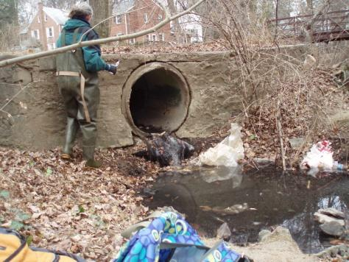Color: Clear, Intensity 1 | 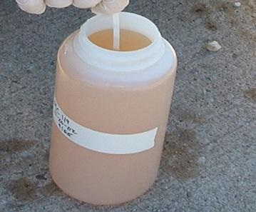Color: Brown, Intensity 2 | 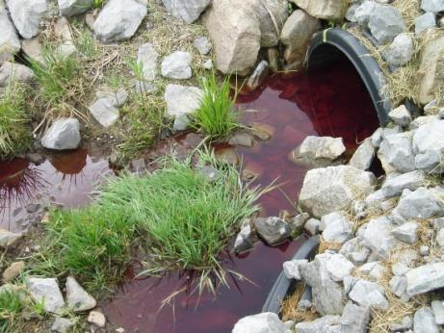  Color: Purple, Intensity 3

Figure 13. Iron Floc
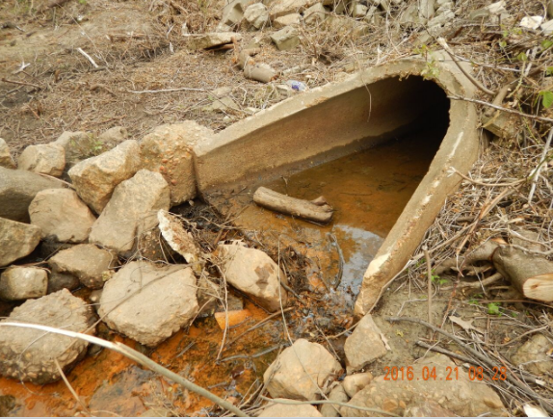  Iron floc in an outfall pipe | 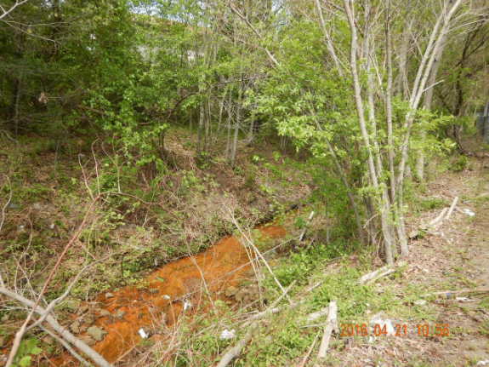  Iron floc in a stream

Turbidity
During inspections, make a visual estimation of the discharge turbidity. Turbidity is a measure of the water cloudiness. Like color, turbidity is best observed in a clear sample bottle and can be quantitatively measured in the field. Field crews should look for turbidity in the pool below the outfall as well as in ditches and note any downstream turbidity plumes that appear to be related to pollution sources. Turbidity can often times be confused with color, which are related but not the same. Turbidity is a measure of how easily light can penetrate through the water sample, whereas color is defined by the tint or intensity of the color observed. See Figure 14 for how to rank turbidity severity.

Score Description
1 Slight cloudiness to the water
2 Cloudy, more difficult to see through the water
3 Water is opaque; cannot see through

Figure 14. Turbidity
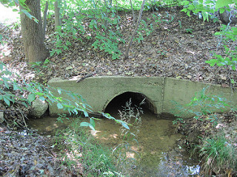 Turbidity Severity: 1 | 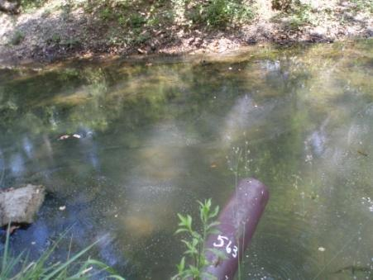 Turbidity Severity: 2 | 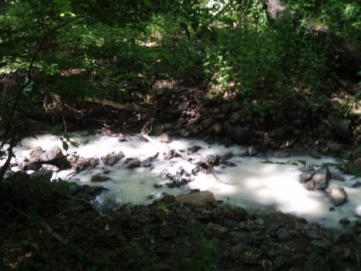  Turbidity Severity: 3

Floatables
Another visual indicator is the presence of any floatable materials in the discharge or the plunge pool below the outfall pipe. Sewage, oil sheen, and suds are all examples of floatable indicators. Trash and debris are generally not floatables in the context of illicit discharge investigations, but should be noted in any case for potential dumping or yard waste concerns (see respective sections above). Some guidelines for ranking their severity are provided.

If you think the floatable is sewage, you should automatically assign it a severity score of 3 since no other source looks quite like it (see Figure 8). Surface oil sheens are ranked based on their thickness and coverage. A thick or swirling sheen associated with a petroleum-like odor indicates a likely oil discharge (Figure 15). In some cases, surface sheens may not be related to oil discharges, but instead are created by natural in-stream processes, such as the example shown in Figure 16. These natural decay sheens will crack and break up when swirled with a stick, but petroleum products will quickly coalesce back together.

Suds are rated based on their foaminess and staying power. A severity score of 3 is designated for thick foam that travels many feet before breaking up (Figure 17). Suds that break up quickly may simply reflect water turbulence, and do not necessarily have an illicit origin. Some streams have naturally occurring foams due to the decay of organic matter. However, suds that are accompanied by a strong organic or sewage-like odor may indicate a sewage leak or illicit connection. If the suds have a fragrant odor, they may indicate the presence of laundry water or other wash waters.

Score Description
1 Few/slight
2 Moderate
3 Severe

Figure 15. Oil Sheens
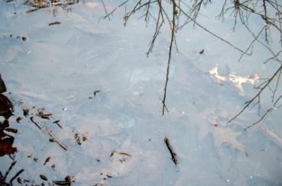  Low Severity Oil Sheen  Score: 1 | Moderate Severity Oil Sheen  Score: 2 | 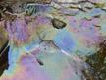  High Severity Oil Film  Score: 3

Figure 16. Natural vs. Synthetic Sheen
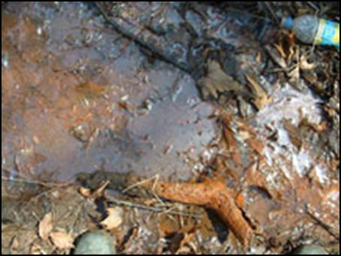  Sheen from bacteria such as iron floc forms a sheet-like film that cracks if disturbed | 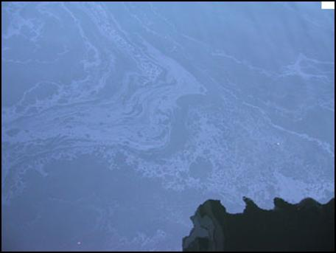  Synthetic oil forms a swirling pattern

Figure 17. Suds
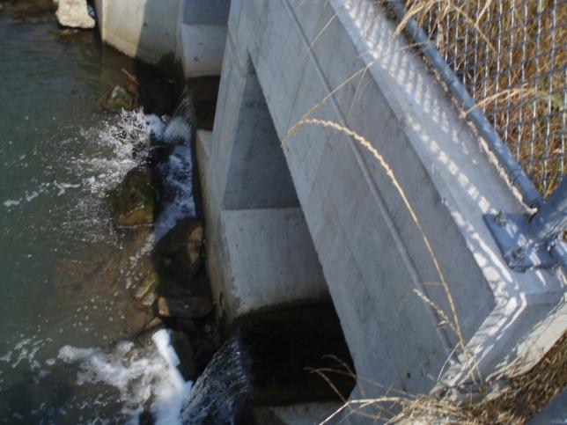Natural Foam - Do not record.  Note: Suds caused by turbulence | 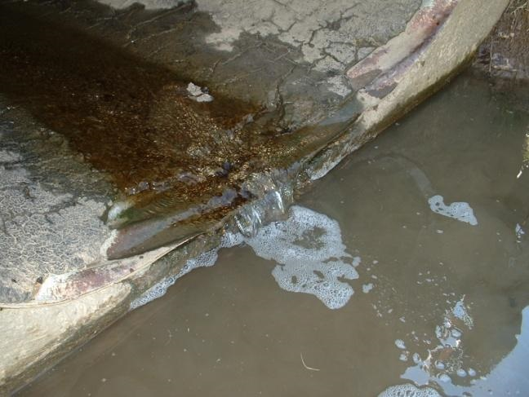  Low Severity Suds – Score: 1  Note: Suds do not appear to travel; very thin foam layer
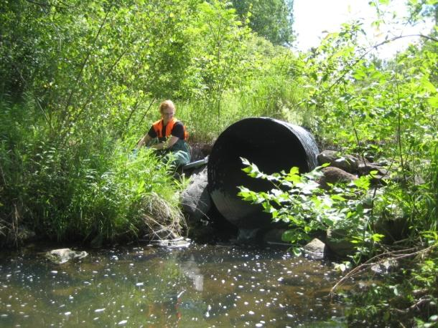Moderate severity suds – Score: 2 | 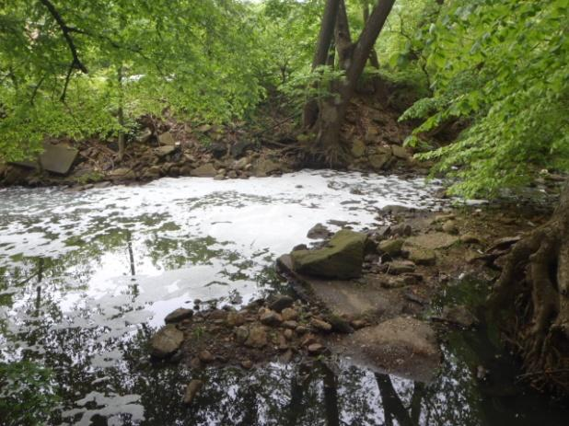High severity suds – Score: 3

5. IDDE WRITTEN PROCEDURES

Purpose/Goal
The chief purpose of these procedures is to help protect local water quality and satisfy the requirements of Minimum Control Measure No.3 of the Phase I MS4 Permit (Section B 2 e) and Phase II MS4 Permit (Section II B 3 c). The procedures provide a framework for MS4s to develop and implement a comprehensive plan to identify and eliminate unauthorized dry weather illicit discharges to their systems.

Adopted from Brown et al. (2004), the protocol relies primarily on visual observations and the use of field test kits and portable instrumentation during dry weather to complete a thorough inspection of the communities’ storm sewers in a prioritized manner. The protocol is applicable to most typical storm sewer systems; however, modifications to materials and methods may be required to address coastal plain and other conditions, such as tidal influence, groundwater intrusion into storm sewers, piped stream networks, systems impacted by sanitary sewer overflows, or situations where groundwater, backwater or other conditions preclude or confound adequate inspection. The primary focus of the protocol is sanitary waste, however, toxic and nuisance discharges may also be identified. Implementation of the protocol would satisfy the relevant conditions of Minimum Control Measure No. 3, illicit discharge detection & elimination (IDDE) of the City/County’s Phase I and/or Phase II NPDES MS4 Permit.

NOTE: The following procedures represent a fairly robust set of practices that would meet or exceed the requirement for “written procedures” in the MS4 General Permit. At points, the procedures intersect with particular sections of the General Permit, and these are noted in the text. Localities should review the procedures in the context of the permit, and modify to meet the capabilities and goals of the local program. In addition, MS4s may wish to consult the Chesapeake Bay Program protocols for TMDL credits for reducing discharges from “Grey Infrastructure” to ascertain whether local programs can obtain additional credits towards needed MS4 pollutant reductions (Schueler et al., 2014). The Nutrient Discharge from Grey Infrastructure Credit side bars in this document refer to potential credits outlined in the Grey Infrastructure protocol:

http://chesapeakestormwater.net/bay-stormwater/baywide-stormwater-policy/urban-stormwater-workgroup/illicit-discharge-detection/

Illegal dumping located at or near an outfall should be reported to the IDDE Coordinator at (757) XXX-XXXX or email.
Needed infrastructure repairs should be reported to the Public Works Department at
(757) XXX-XXXX or email.

Detection
Illicit discharges can be detected in several ways: citizen complaints, during regular dry weather screening, and during other routine activities conducted by staff. Procedures to be followed at the storm drain or outfall do not differ greatly based on the type of detection. These procedures are discussed below.

Outfall Inspections
Outfall inspections are to be conducted when at least 48 hours has passed since the last precipitation event, generally an event of greater than 0.1”, unless responding to a citizen complaint or spill. Safety precautions are to be undertaken during the inspection, including:

- Wearing protective gloves;
- Wearing protective goggles if chemical testing takes place;
Nutrient Discharges from
Grey Infrastructure Credit

Direct measurements of Flow and Nutrient Concentration are required prior to removal for the following discharge types:
- Laundry washwater*
- Commercial car washwater
- Floor drains
- Miscellaneous high nutrient discharges
- Sanitary direct connection

*Can use default values for nutrients
- Placing traffic cones and using flashers, lights, and other traffic control measures if needed;
- Using caution on slopes and at the edge of waterbodies;
- Disposing of chemical reagents or other waste as indicated on material safety data sheets; and
- Not entering manholes or storm sewers without confined space training.

Autumn (after leaf fall) is the ideal time to conduct outfall inspections. Vegetation is less likely to obstruct views of outfalls and groundwater influences may be diminished. Outfall inspections may be conducted during other seasons, but be aware of the following:
- Winter: frozen flows, cold temperatures affecting sampling equipment, and possible effect of snow melt and/or road salt on sample results.
- Spring: high groundwater table may lead to more flowing outfalls that originate from springs in addition to more groundwater inundation of the storm sewer system.
- Summer: vegetation may obstruct outfalls, air conditioning condensate may lead to more flowing outfalls (AC condensate is not considered an illicit discharge unless deemed by the MS4 to be a “significant contributor of pollutants” (see authorized discharges in Section 3 of this manual)).

Submerged Outfalls & Monitoring Stations
In the coastal plain, many outfalls are submerged due to the flat relief. This can make it difficult to identify, access or to effectively sample these outfalls. Some options include:

- Sample During Low Tide
In tidal waters, surveys should be conducted at low tide. This exposes outfalls that may be hidden during high tide.

- Take Samples from Further Up the Pipe
Many of the observations that are helpful for identifying illicit discharges are difficult to identify in submerged outfalls or storm sewer structures with groundwater inundation. For example, one key indicator is whether the pipe is flowing or non-flowing. By walking further up the pipe or storm system, investigators can determine if the pipe is flowing.

- Conduct field surveys by boat or from the shore
Another challenge at submerged outfalls is that they can be difficult to access. One solution to this problem is to conduct outfall surveys by kayak or canoe in deep waters. Alternatively, outfalls can be accessed by walking along the shore.

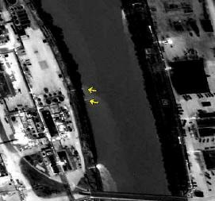
- Use Aerial Infrared Imagery to Identify discharges
Aerial infrared imagery can help to identify continuous discharges (Figure 18). This technique is helpful for submerged outfalls that may be missed, even when flowing. This technique should always be followed up with sampling to ground truth the initial findings. Aerial infrared imagery can be obtained from fly-overs or existing imagery can be inspected from sources such as the US Geological Survey.

- Supplement with Chemical Monitoring
In non-submerged or non-inundated outfalls or structures, physical characteristics (e.g., color and odors) can be excellent indicators of the discharge potential. the contaminant source can still be relatively concentrated. However, in submerged outfalls and inundated structures, the flow is immediately diluted, and it becomes difficult to identify all but the most contaminated sources. Collecting samples for the lab will be helpful at these sites. The most useful parameters at submerged outfalls or inundated structures are bacteria (E. coli, Enterococcus, total coliform, etc.), ammonia and optical brighteners.
Figure 18: Four discharges to the river appear as white plumes. The two discharges highlighted with arrows were unknown discharges. (Source: http://www.excel.net/~jdh/products1.html)

At the outfall/structure, look for visual indicators of illicit discharges like those described in Section 4. Complete the Outfall Reconnaissance Inventory (ORI) form (see Appendix A), or similar field or electronic form, to record your observations.

If the outfall is not already in the jurisdiction’s mapping system, collect GPS coordinates, and assign it a unique identifier code. Consider marking this code on the outfall with spray paint or waterproof marking stick in a prominent location such as the outfall headwall. This will help field crews identify specific outfalls in the future. New outfalls and unmapped stormwater infrastructure should be updated in the jurisdiction’s master GIS system as soon as possible after identification. Stormwater pipe mapping should note the direction of flow in addition to pipe location.

Water Sampling
If the outfall has dry weather flow, take photos and collect a water sample as follows. Jurisdictions may wish to adopt specific Standard Operating Procedures (SOP) for water sampling and other aspects of the IDDE program. An example SOP for water sampling can be found in Appendix B.

If possible, collect water from the flow directly in a clean glass bottle or, for bacteria analysis, a sterile plastic bottle or bag. If using a re-usable bottle, be sure to rinse the bottle and its cap one to three times with sample water for conditioning. If a dipper, bailer, bucket, or other device is used to collect a sample, be sure that they are also conditioned with the flow prior to final collection. Collect enough water to conduct all your field and laboratory tests, plus some extra for good measure.

Label each sample bag or bottle with the appropriate outfall ID, date and time of collection, and sample collector initials using a water-proof marker. (It is easier to label these BEFORE filling the containers.) Bacteria samples are to be kept on ice and processed within a certain amount of time after collection – usually within 6 hours, but refer to bacteria kit or lab instructions for specific holding times. Other lab samples may also need to be kept on ice; consult the laboratory for special instructions. See Table 2 for typical water sampling parameters, common holding times and methods for handling water samples for different parameters.

Table 2. Holding Times for Water Samples for Lab Analysis
Parameter | Water Type | Holding Time | Notes
Bacteria | Fresh or salt | 6 hours | Cool, 4ºC; Enterococcus preferred for salt water
Ammonia | Fresh or salt | Process immediately | Can preserve with sulfuric acid and hold for 28 days; Additional reagent needed for salt water processing
Fluoride | Fresh | 28 days (HDPE plastic container only) | Cool, 4ºC
Anionic Surfactants | Fresh | 2 days | Cool, 4ºC
Potassium | Fresh | 6 months | Frozen
Total nitrogen / Total phosphorus | Fresh or salt | 24 hours  30 days | Cool, 4ºC  Frozen below -20ºC
pH | Fresh or salt | Process immediately
Temperature | Fresh or salt | Process immediately
Optical Brighteners | Fresh or salt | Process immediately

Measuring Flow Rate
If possible, approximate flow measurements should be collected at each flowing outfall. Flow measurements are most critical if the MS4 wishes to take credit for eliminating an illicit discharge (see Grey Infrastructure sidebars) because flow is used to calculate the credit. In other cases, some approximation of flow is still helpful to classify and prioritize illicit discharge issues.

The methods to be used are listed in priority preference below.

- Volume-based – a 1-liter container jug or 5-gallon bucket is filled and the time taken to fill it is recorded with a stopwatch. Flow rate is obtained by converting liters or gallons to cubic feet and then dividing the volume by time. If the flow is difficult to obtain, a “spout” can be molded from plumber’s putty to direct the flow into the measuring container.
- Weir equation – average depth of flow and wetted width are collected at the outfall and the results are input into the equation:
Q in cubic feet per second = 3.1 x wetted width (feet) x depth (feet) ^ 1.5
Note: This method should only be used with a free-flowing outfall (i.e. water drops out of the pipe and falls to the stream channel) and when the depth of flow is relatively uniform.
- Cross-sectional area – the cross-sectional area of the water is obtained by collecting the wetted width and average depth of water and multiplying the results. Velocity is obtained by using a stopwatch to measure the time it takes for a ping pong ball or other buoyant object to flow over a known distance. The velocity measurement is repeated 3-5 times and the results averaged. Flow is obtained by multiplying cross-sectional area by velocity.
- Tidally influenced outfalls – Collecting flow from a tidally influenced outfall or structure can be difficult. If the pipe invert is exposed (dry) during low tide, flow can be collected at that time. If the pipe invert is not exposed during low tide, check each succeeding upstream manhole until no or minimal tidal influence is noted. This same procedure can be followed for storm sewers that are inundated with groundwater. Flow can then be collected using the cross-sectional area equation above. If it is difficult to collect wetted width, water depth and/or velocity at the manhole, the measures can be collected as visual estimates and noted as such on the data collection sheet. A manhole inspection light and mirror kit can be useful for obtaining estimates.

Regular inspections of outfalls or storm drains are a primary part of an effective IDDE program and a regular schedule of long-term inspections for outfalls should be maintained. The Phase I Permit requires dry weather screening in areas of concern as identified by the permittee (e.g. commercial car washes, car dealerships, pet kennels, restaurants, areas with a history of complaints). The Phase I permittee shall screen, at a minimum, 50 stations each year. The Phase II MS4 Permit requires a prioritized schedule of field screening activities determined by the operator based on such criteria as age of the infrastructure, land use, historic illegal discharges, dumping, or cross connections (Section II B 3 c 1 a). If the Phase II MS4 has less than 50 outfalls, all should be screened on an annual basis. For communities with 50 or more outfalls, a minimum of 50 should be screened annually.

Non-routine Inspections
If an employee observes evidence of an illicit discharge during an informal or non-routine inspection, he/she should collect as much information (including photos) about the potential illicit discharge as possible and then contact his/her supervisor or dispatch office so that appropriate action can be taken. A tracking sheet or spreadsheet (example provided in Table 3) can be used to collect the information observed. While it may not be reasonable to expect all field employees to have copies of the form with them at all times, there are other ways to collect the information:

- The person observing the discharge can provide the information verbally to dispatch or the supervisor, who can then complete the Illicit Discharge Tracking Sheet;
- The person can log as much information as they can recall onto the form upon returning to the office; or
- A third party (such as a code enforcement officer) dedicated to inspecting and tracing illicit discharges can be sent to the location as soon as possible where the potential illicit discharge was observed to collect the necessary information directly on the form.

Table 3. Illicit Discharge Tracking Sheet
Date Illicit Discharge Observed & Reported: | Report Initiated by: Phone, drop-in, contact information, etc. | Location of Discharge: If known – lat/long, stream address or outfall #, nearby landmark, etc. | Description of Discharge: E.g. – dumping, wash water suds, oil, etc. | Actions to be Taken: Who What, When and How…(what should be done) | Results & Follow-Up of Investigation: Outcome of actions taken and any necessary follow-up (what was done) | Date Investigation Resolved or Closed:

It is important to collect as much information as possible at the time of initial observation because of the likelihood that a discharge may be transitory or intermittent. Initial identification of the likely or potential sources of the discharge is also very important.

Potential outfall investigation scenarios include:

- No discharge present, no evidence of previous illicit discharge – Action: record and proceed to next outfall.
- No discharge present, evidence of previous illicit discharge – Action: schedule for re-investigation in one month.
- Discharge present – Action: note apparent quality of discharge, take field or lab samples for chemical analysis if necessary and, if appropriate, begin source tracking phase.

Drainage Area and Storm Drain Investigations
An illicit discharge investigation is to be conducted if any of the following apply:
- The overall outfall characterization as determined by the ORI (Appendix A) is determined to be “suspect” or “obvious.”
- On-site or lab water testing results in values that exceed established thresholds. General thresholds are indicated in Table 4 and Figure 19. The framework for a chemical fingerprint library for Hampton Roads can be found in Appendix C. Note that analysis should begin with a determination of the salinity concentration. Salt water creates interference for many monitoring parameters, ammonia in particular. For some parameters, such as ammonia, special kits are needed for salt or brackish water. In addition, some probes may not function at high salinity rates, and program designers need to search for other options.
- If the outfall is determined to have “potential” illicit discharges based on completion of the ORI, the outfall should be re-visited three additional times during the permit cycle to determine if an intermittent discharge may be present. Ideally, one re-visit will occur on a different day of the week than the original visit and/or at a different time of day.

Table 4. Dry weather outfall screening suggested water quality indicators
Screening Parameter | Potential Source | Salt Water Consideration | Threshold
Ammonia | Washwater, Wastewater or Industrial | Additional reagent may be required for test kits | >0.5 mg/l
Fluoride | Tap Water | Most test kits not suitable for use in salt water | >0.25 mg/l
Detergents | Wastewater, Washwater or Industrial | Most test kits not suitable for use in salt water | >0.25 mg/l
Optical Brighteners | Washwater, Wastewater | Detergent alternative for use in salt water but results may be confounded by organic matter | >15RFU
Bacteria | Washwater, Wastewater | Enterococcus preferred in salt water | >10,000 CFU
Chlorine | Tap Water | Check test kits for suitability of use in salt water | >0.1 mg/L
pH | Washwater, Industrial | pH strips not appropriate for salt water, use colorimetric techniques or probe | ≤5
Temperature | n/a | n/a | n/a

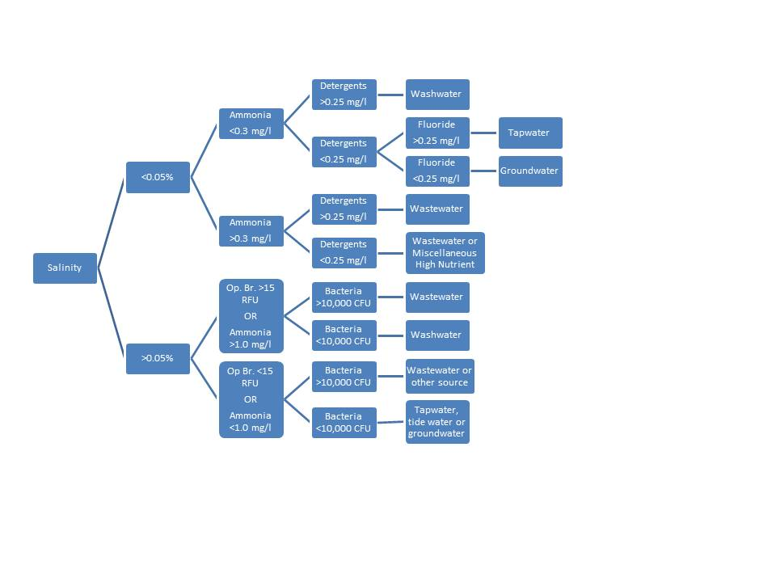
Figure 19. Flow chart method to determine if flow has an illicit discharge, based on thresholds for different parameters.

If an illicit discharge is detected at an outfall, an investigation will be conducted to isolate the source of the discharge. These investigations should commence within XX days of the initial identification of any observed continuous or intermittent potential illicit discharges. Based on the MS4 Permit, potential illicit discharges from sewage or that are “significantly contaminated” must be investigated first (see severity ratings in Section 4, Illicit Discharge Characteristics). Potential illicit discharges that are deemed less hazardous to human health and safety (e.g., washwater) should be investigated, but as a secondary priority (Section II B 3 c 1 d).
Nutrient Discharges from
Grey Infrastructure Credit

Step 1: Concentration – Obtain water samples, duplicates, and flow measurements from an illicit discharge source

Step 2: Average Daily Flow – Convert cfs to gpd for flow measurement (daily flow)
1 cubic foot = 7.48 gallons
86,400 seconds/day
0.006 cf/second x 7.48 gallons/cf x 86,400 seconds/day = gallons/day (average daily flow)

Step 3: Conversion Factor – Understand conversion factor for concentration: mg/L to lbs/gallon
1 mg = 2.205 x 10⁻⁶ lbs
1 L = 0.264 gallons
1 mg/L = 2.205 x 10⁻⁶ lbs/mg / 0.264 gallons/L = 8.345 x 10⁻⁶

Step 4: Duration – Calculate days/year of the discharge: assume laundry flow from building 25% of the year based on interview with building manager
365 days/year x 0.25 = days/year

Step 5: Annual Load Reduced – Calculate lbs/year of eliminated discharge
TN Load = Step 1 Average concentration x Step 2 gallons/day x Step 3 Conversion factor x Step 4 days/year = lbs/year

TP Load = Step 1 Average concentration x Step 2 gallons/day x Step 3 Conversion factor x Step 4 days/year = lbs/year

The process for tracking a transient discharge (e.g., that enters the storm drain system directly through dumping or spills from the landscape) will follow the procedure for a Drainage Area Investigation. Tracking a continuous or intermittent discharge that likely occurs from direct or indirect entry into the storm drain system from the interaction of pipes underground will follow the procedure for a Storm Drain Investigation. Either investigation should be conducted during dry weather as described previously.

Public notification may be required in either type of investigation. If right of entry onto private property is required, the jurisdiction will provide a letter/mailer to residents and property owners located in the vicinity, notifying them of the scope and schedule of investigative work, and the potential need to gain access to their property to inspect plumbing fixtures.

Drainage Area Investigation
A survey by vehicle (“windshield survey”) of the drainage area may be used to find the potential source of pollution if the discharge observed at an outfall has distinct or unique characteristics that allow crews to quickly ascertain the probable operation or business that is generating it (Brown et al, 2004). Discharges with a unique color, smell, or off-the-chart indicator sample reading may point to a specific industrial or commercial source. For example, if fuel is observed at an outfall, crews might quickly check every business operation in the drainage area that stores or dispenses fuel. The drainage system map will be useful for this investigation.

In larger or more complex drainage areas, GIS data can be analyzed to pinpoint the potential sources of a discharge. If only general land use data exist, maps can at least highlight suspected industrial areas. If more detailed SIC code data are available digitally, the GIS can be used to pull up specific hotspot operations that could be potential dischargers.

Storm Drain Investigation
Adequate storm and sanitary sewer mapping is a prerequisite to properly execute a storm drain investigation. As necessary and to the extent possible, infrastructure mapping should be verified in the field and corrected prior to investigations. This effort affords an opportunity to collect additional information such as latitude and longitude coordinates using a global position system (GPS) unit, if so desired. To facilitate subsequent investigations, tributary area delineations should be confirmed and junction manholes should be identified during this process.

Field crews strategically inspect manholes within the storm drain network system to measure chemical or physical indicators that can isolate discharges to a specific segment of the network. Once the pipe segment has been identified, on-site investigations are used to find the specific discharge or improper connection. This method involves progressive sampling at manholes in the storm drain network to narrow the discharge to an isolated pipe segment between two manholes. Field crews need to make two key decisions when conducting a storm drain network investigation—where to start sampling in the network and what indicators will be used to determine whether a manhole is considered “clean” or “dirty”.
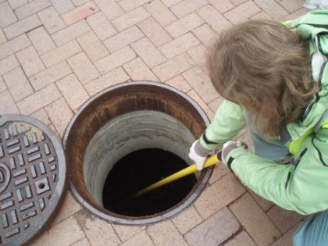
The field crew can sample the pipe network in one of three ways:

- Crews can work progressively up the trunk from the outfall and test manholes along the way.
- Crews can split the trunk into equal segments and test manholes at strategic junctions in the storm drain system.
- Crews can work progressively down from the upper parts of the storm drain network toward the problem outfall.

During a manhole inspection, manholes are opened and inspected for visual evidence of contamination. Where flow is observed, and determined to be a potential illicit discharge through visual indicators and/or use of water testing equipment, the upstream tributary storm sewer system is isolated for investigation (e.g. further flow inspection, dye testing, CCTV). Manholes are inspected until the observed flow is determined to be uncontaminated or until all upstream illicit connections are identified and removed.

For Phase II MS4 permittees, where flow is not observed, but an intermittent discharge is suspected, the MS4 Permit requires documentation of at least 3 separate investigations to observe the potential intermittent discharge, and proper documentation of those investigations (Section II B 3 c 1 e). No specific requirements are made of Phase I permittees with regards to intermittent discharges.

Another method to locate and identify intermittent discharges attempts to contain the flow when it occurs. This method will likely require confined space entry procedures for entering junction manholes. All inlets to the structure should be partially dammed for 48 hours when no precipitation is forecasted. Inlets are damed by blocking a minimal percentage of the pipe diameter at the invert using sandbags, caulking, weirs/plates, or other temporary barriers. The manholes are thereafter re-inspected (prior to any precipitation or snow melt) for the capture of periodic or intermittent flows behind any of the inlet dams. The same visual observations and field testing is completed on any captured flow, and where contamination is identified, abatement is completed prior to inspecting downstream manholes.

Where flow is observed and does not demonstrate obvious indicators of contamination, samples are collected and analyzed and then compared with established benchmark values (see examples in Table 4 and Figures 18) to determine the likely source of the flow. This information facilitates the investigation of the upstream storm sewer system. Benchmark values may be refined over the course of investigations as the community develops a better sense of local threshold values for given indicators. In those manholes where periodic or intermittent flow is captured through damming inlets, additional laboratory testing (e.g. toxicity, metals, etc.) should be considered where an industrial discharge is suspected.

To facilitate investigations, storm drain infrastructure should possibly be cleaned to remove debris or blockages that could compromise investigations. Such material should be removed to the extent possible prior to investigations, however, some cleaning may occur concurrently as problems manifest themselves.

Isolation and confirmation of illicit sources
Where field monitoring has identified storm sewer systems to be influenced by sanitary flows or washwater, the tributary area is isolated for more detailed investigations. Additional manholes along the tributary are inspected to refine the longitudinal location of potential contamination sources (e.g. individual or small blocks of homes or businesses). Targeted internal plumbing inspections, dye testing, smoke testing or CCTV inspections are then employed to more efficiently confirm discrete flow sources. More information on these techniques can be found in Brown et al (2004), and as specified by local policies and legal authority (Section II B 3 c 1 f).
Nutrient Discharges from
Grey Infrastructure Credit

Verification of illicit discharge elimination is necessary for crediting purposes. Typical verification requirements:
- Confirmation inspection after elimination
- Inclusion in annual outfall screening for one to two years after elimination.

Per City/County Code, upon determination of the source, the City/County notifies the apparent responsible party that a violation of the stormwater ordinance exists. Voluntary compliance is the preferred response. If voluntary compliance cannot be achieved through negotiation, the program administrator may initiate formal enforcement action as specified in the local ordinance.

Post-Removal Confirmation (Section II B 3 c 1 g)
After completing the removal of illicit discharges from a subdrainage area, the subdrainage area is re-inspected to verify corrections. Depending on the extent and timing of corrections, verification monitoring can be done at the initial junction manhole or the closest downstream manhole to each correction. Verification is accomplished by using the same visual inspection, field monitoring, and damming techniques as described above.

Program Tracking, Reporting & Evaluation
The program must include a mechanism to track and document all investigations (Section II B 3 c 1 h). Table 3 or similar spreadsheet, database, or MS4 tracking program can be used for this purpose. The permit also contains specific MS4 reporting elements (Section II B 3 f).

The MS4 may wish to track additional elements in order to evaluate the program and make efficiency improvements through time. Below is a list of possible tracking metrics:

- Number/% of manholes/structures inspected
- Number/% of outfalls screened
- Number/% of illicit discharges identified through:
- visual inspections
- field testing results
- temporary damming (intermittent discharges)
- Number/% of homes inspected/dye tested
- Footage/% of pipe inspected by CCTV
- Number/% of illicit discharges removed
- Estimated flow/volume of illicit discharges removed
- Footage and location of infrastructure jetting/cleaning required
- Infrastructure defects identified and repaired
- Water main breaks identified and repaired
- Cost of illicit discharge removals (total, average unit costs)

References
Boston Water & Sewer Commission, 2004, A systematic Methodology for the Identification and Remediation of Illegal Connections. 2003 Stormwater Management Report, chap. 2.1.

Brown, E., D. Caraco and R. Pitt. 2004. Illicit Discharge Detection and Elimination: a guidance manual for program development and technical assessments. Center for Watershed Protection and University of Alabama. EPA X-82907801-0.U.S. EPA Office of Wastewater Management, Washington, D.C.

Commonwealth of Virginia. 2013. General Permit for Discharges of Stormwater From Small Municipal Separate Storm Sewer Systems. General Permit No. VAR04. 4VAC25-890-40.

Commonwealth of Virginia. 2013. Small Municipal Separate Storm Sewer Systems. 9VAC25-870-400.

Dorfman, Mark & Kirsten Sinclair Rosselot. 2011. Testing the Waters: A Guide to Water Quality at Vacation Beaches. Natural Resources Defense Council. http://www.nrdc.org/water/oceans/ttw/titinx.asp

Environmental Protection Agency. 1986. Ambient Water Quality Criteria for Bacteria. EPA440/5-84-002.

Lilly, Lori and Paul Sturm. 2010. Technical Memorandum: Illicit Discharge Monitoring in Baltimore Watersheds. Center for Watershed Protection. Ellicott City, MD.

Schueler, T., C. Lane, and B. Stack. 2014. Recommendations of the Expert Panel to Define Removal Rates for the Elimination of Discovered Nutrient Discharges from Grey Infrastructure, Final Approval Report. September 23, 2014.

Appendix A: Outfall Reconnaissance Inventory (ORI) Form

Outfall Reconnaissance Inventory/ Sample Collection Field Sheet (coastal)
Section 1: Background Data
Subwatershed: |  |  | Outfall ID:
Today’s date: |  |  | Time (Military):
Investigators: |  |  | Form completed by:
Temperature (°F): |  | Rainfall (in.): Last 24 hours: Last 48 hours:
Latitude: | Longitude: |  | GPS Unit: | GPS LMK #:
Camera: |  |  | Photo #s:
Land Use in Drainage Area (Check all that apply):

Industrial Commercial Open Space Ultra-Urban Residential Institutional Suburban Residential

Other: Known Industries: ___________

Notes (e.g., origin of outfall, if known):

Section 2: Outfall or Monitoring Station Description
Location | Material | Shape/Structure |  | Dimensions (in.) | Conditions
Closed Outfall Pipe  Manhole Structure  Open drainage  In-Stream | RCP Earthen  CMP Rip-Rap  PVC HDPE  Brick Concrete  Steel  Other: | Circular  Elliptical  Box  Manhole shaft (vertical)  Open Drainage:  Trapezoid  Parabolic  Other: | Single  Double  Triple  Other: | Diameter, circular:  Dimensions,  Box: h - w -  Elliptical: h - w -  Open Drainage:  Depth:  Top Width:  Bottom Width:  Manhole Structure:  Depth from rim to invert -  Depth from rim to water (if present) -  Inundation level: inches | Tide (as applicable):  Low  High  In Between  Submerged Outfall:  No  Partially  Fully  Sediment in Outfall:  No  Partially  Fully  Manhole Structure:  Dry  Tidal water  Groundwater  Not Sure

Flow Present? Yes No Tidal Flushing If No or Tidal Flushing, Skip to Section 5 If present, go to Sections 3 & 4.

Note: For structures inundated with tidal or groundwater, check flow visually or by stick rule/measuring tape
Flow Description (if present): Trickle Moderate Substantial

Section 3: Quantitative Characterization
FIELD DATA FOR FLOWING OUTFALLS
PARAMETER |  | RESULT | UNIT | EQUIPMENT
Flow #1 | Volume |  | Liter | Bottle
 | Time to fill |  | Sec | Stopwatch
Flow #2 | Flow depth | 1. 2. 3. 4. | In | Tape measure
 | Flow width | ’ ” | Ft, In | Tape measure
 | Measured length | ’ ” | Ft, In | Tape measure
 | Time of travel | 1. 2. 3. 4. | S | Stop watch
Temperature |  |  | °F | Thermometer
Ammonia |  |  | mg/L | Specific ion probe (see instructions)
Salinity |  |  | ppm | Refractometer
Conductivity |  | Dilution? % | μs | Conductivity meter

Outfall Reconnaissance Inventory/ Sample Collection Field Sheet (coastal)

Section 4: Physical Indicators for Flowing Outfalls Only
Are Any Physical Indicators Present in the flow? Yes No (If No, Skip to Section 5)
INDICATOR | CHECK if Present | DESCRIPTION | RELATIVE SEVERITY INDEX (1-3)
Odor |  | Sewage Rancid/sour Petroleum/gas Chemical/solvent  Sulfide Chlorine/fruity Other: | 1 – Faint | 2 – Easily detected | 3 – Noticeable from a distance
Color |  | Clear Brown Gray/milky Yellow  Green Orange Red Other: | 1 – Faint colors in sample bottle | 2 – Clearly visible in sample bottle | 3 – Clearly visible in outfall flow
Turbidity |  | See severity | 1 – Slight cloudiness | 2 – Cloudy | 3 – Opaque
Floatables  -Does Not Include Trash!! |  | Sewage (Toilet Paper, etc.) Suds  Petroleum (oil sheen) Other: | 1 – Few/slight; origin not obvious | 2 – Some; indications of origin (e.g., possible suds or oil sheen) | 3 - Some; origin clear (e.g., obvious oil sheen, suds, or floating sanitary materials)

Section 5: Physical Indicators for Both Flowing and Non-Flowing Outfalls OR Manholes With Tidal or Groundwater Inundation
Are physical indicators that are not related to flow present? Yes No (If No, Skip to Section 6)
 | INDICATOR |  | CHECK if Present |  | DESCRIPTION |  | COMMENTS
 | Outfall or Structure Damage |  |  |  | Spalling, Cracking or Chipping Peeling Paint Corrosion
 | Deposits/Stains |  |  |  | Oily Flow Line Paint Sewage fungus Other:
 | Odor |  |  |  | Sewage Rancid/sour Petroleum/gas Chemical/solvent  Sulfide Chlorine/fruity Other:
 | Abnormal Vegetation |  |  |  | Excessive Inhibited
Poor quality of water in pool or manhole |  |  |  | Odors Colors Floatables Oil Sheen  Suds Excessive Algae Other:
Pipe or manhole benthic growth |  |  |  | Brown Orange Green Gray, Milky White Other:

Section 6: Overall Outfall Characterization
Unlikely Potential (presence of two or more indicators) Suspect (one or more indicators Obvious

Section 7: Data Collection
1. Sample for the lab? Yes No 2. Sterile sample for bacteria analysis? Yes No 3. If yes, collected from: Flow Pool Manhole
4. Sample for optical brightener? Yes No 5.Intermittent flow trap set? Yes No If Yes, type: OBM Caulk dam 6. Duplicate collected? Yes No

Section 8: Other Concerns (e.g., trash, needed infrastructure repairs, etc.)?

Appendix B: Representative IDDE Standard Operating Procedures

EXAMPLE Water Sampling Standard Operating Procedure
Person responsible: |  |  |  | IDDE Coordinator
Area of application: |  |  |  | MS4
Document location: |  |  |  | xxxx
Original issue date: |  |  |  | xxxx
Revisions
Rev. No. |  |  | Date | Description |  | Reviewed by
Recurring action items
Activity |  |  |  |  | Responsibility |  | Frequency
Water Sample Collection SOP |  |  |  |  | IDDE Coordinator |  | Annually
 | Procedure Index |  |  |  |  |  |  | Page
 | 1.0 Purpose |  |  |  |  |  |  | x
 | 2.0 Scope |  |  |  |  |  |  | x
 | 3.0 Responsibility |  |  |  |  |  |  | x
 | 4.0 Definitions |  |  |  |  |  |  | x
 | 5.0 Procedures |  |  |  |  |  |  | x
 |  | 5.1 Precautions |  |  |  |  |  | x
 |  | 5.2 Field Procedure |  |  |  |  |  | x
 |  | 5.3 Sample Handling Procedure |  |  |  |  |  | x
 |  | 5.4 Task Specific Requirements |  |  |  |  |  | x
 |  | 5.5 Safety |  |  |  |  |  | x
 |  | 5.6 Equipment and Supplies |  |  |  |  |  | x
 | 6.0 References / Related Documents |  |  |  |  |  |  | x

1.0 Purpose
1.1 |  |  | To assist managers and field crews to collect water samples from storm water drainage system (MS4) outfalls and surface waters.
2.0 Scope
2.1 |  |  | This procedure is applicable to thoses assisting with MS4 permit and outfall inventory and illicit discharge screening activities.
3.0 Responsibility
3.1 |  | IDDE Coordinator is responsible for:
 |  | 3.1.1 |  | Ensuring the proper approved forms are used;
 |  | 3.1.2 |  | Facilitating training for all staff;
 |  | 3.1.3 |  | Ensuring that all records and documents are properly maintained, controlled and distributed.
3.2 |  | IDDE Inspectors and Technicians are responsible for:
 |  | 3.2.1 |  | Reading, understanding and following this SOP
 |  | 3.2.2 |  | Conducting field activities and sample collection
 |  | 3.2.3 |  | Completing appropriate forms
4.0 Definitions
4.1 |  |  | MS4: Municipal Separate Storm Sewer System. A conveyance or system of conveyances (including roads with drainage systems, municipal streets, catch basins, curbs, gutters, ditches, man-made channels, or storm drains):  (i) Owned or operated by a state, city, town, borough, county, parish, district, association, or other public body;  (ii) Designed or used for collecting or conveying stormwater;  (iii) Which is not a combined sewer; and  (iv) Which is not part of a Publicly Owned Treatment Works (POTW) as defined at 40 CFR 122.2.
4.2 |  |  | Outfall: A point where a storm water conveyance discharges into rivers, bays, streams, lakes, and/or wetlands.
4.3 |  |  | Chain of Custody: A written record documenting the location of the sample at all times from handling of the samples through various stages of storage, processing, and analysis at the laboratory.
4.4 |  |  | Illicit Discharge Detection and Elimination Personnel (IDDEP): Environmental Compliance Officer and DPU Environmental Inspectors and Technicians.
5.0 Procedures
5.1 |  | Precautions
 |  | 5.1.1 |  | Special care must be taken not to contaminate samples. This includes storing samples in a secure location to preclude conditions which could alter the properties of the sample. Samples shall be custody sealed during long-term storage or shipment.
 |  | 5.1.2 |  | Collected samples are in the custody of the sampler or sample custodian until the samples are relinquished to another party.
 |  | 5.1.3 |  | Documentation of field sampling is done in a bound logbook.
 |  | 5.1.4 |  | Chain-of-custody documents shall be filled out and remain with the samples until custody is relinquished.
 |  | 5.1.5 |  | A clean pair of new, non-powdered, disposable gloves will be worn each time a different location is sampled and the gloves should be donned immediately prior to sampling. The gloves should not come in contact with the media being sampled and should be changed any time during sample collection when their cleanliness is compromised.
5.2 |  | Field Procedure
 |  | 5.2.1 |  | Surface water samples will typically be collected either by directly filling the container from the surface water body being sampled or by decanting the water from a collection device such as a stainless steel scoop or other device.
 |  | 5.2.2 |  | Place the sample into appropriate, labeled containers.
 |  | 5.2.3 |  | All samples requiring preservation must be preserved as soon as practically possible, ideally immediately at the time of sample collection.
 |  | 5.2.4 |  | The physical location of the investigator when collecting a sample may dictate the equipment to be used. If surface water samples are required, direct dipping of the sample container into the stream is desirable. If the stream is too deep to wade, or if the sample must be collected from an elevated platform (bridge, pier, etc.), supplemental sampling equipment must be used. Supplemental sampling equipment may also be used when collecting samples from an outfall.
 |  | 5.2.5 |  | A sample may be collected directly into the sample container when the surface water source is accessible by wading or other means. The sampler should face upstream if there is a current and collect the sample without disturbing the bottom sediment. The surface water sample should always be collected prior to the collection of a sediment sample at the same location.
 |  | 5.2.6 |  | Stainless steel scoops provide a means of collecting surface water samples from surface water bodies that are too deep to access by wading or from outfalls that are otherwise inaccessible. The scoop may be used directly to collect and transfer a surface water sample to the sample container.
 |  | 5.2.7 |  | A plastic bucket can be used to collect samples for measurement of water quality parameters such as pH, temperature, and conductivity. Samples collected for analysis of classical water quality parameters including but not limited to ammonia, nitrate-nitrite, phosphorus, and total organic carbon may also be collected with a bucket. Typically, a bucket is used to collect a sample when the water depth is too great for wading, it is not possible to deploy a boat, or access is not possible (excessive vegetation or steep embankments) and the water column is well mixed. The water body is usually accessed from a bridge. The bucket is normally lowered by rope over the side of the bridge. Upon retrieval, the water is poured into the appropriate sample containers Caution should be exercised whenever working from a bridge. Appropriate measures should be taken to ensure the safety of sampling personnel from traffic hazards.
5.3 |  | Sample Handling Procedure
 |  | 5.3.1 |  | Each person who relinquishes or receives samples sign the Chain Of Custody form for the samples. The samples should be handled only by persons associated in some way with the monitoring program.
 |  | 5.3.2 |  | Once the samples arrive at their destination and at every custody change, the samples should first be checked to ensure that their integrity is intact. The contents of the shipment should be checked against the COC form to ensure that all samples listed were included in the shipment. The levels of liquid samples should be compared to original levels (if marked on the container or recorded), to identify whether major leaks have occurred.
 |  |  |  | Any samples whose integrity or identity are questionable should be brought to the attention of the relinquisher and flagged. All flags should be “carried” along with the samples until the validity of the samples can be proven. This information can be included in the remark section of the Chain of Custody form.
5.3 |  | Task Specific Requirements
 |  | 5.3.1 |  | Familiarity with water sampling procedures
 |  | 5.3.2 |  | Ability to navigate rough terrain and work in varying conditions outdoors
5.4 |  | Safety
 |  | 5.4.1 |  | Do not enter swiftly moving water that is more than 6 inches deep
 |  | 5.4.2 |  | Be on the lookout for and avoid poison ivy, ticks, spiders, dogs, snakes and other wildlife
 |  | 5.4.3 |  | Be careful when attempting to cross wet rocks, concrete or wood as the surface may be extremely slippery
 |  | 5.4.4 |  | Enter an ICE (In Case of Emergency) number into your cell phone and have it set in speed dial
 |  | 5.4.5 |  | Wear rubber boots or waders at all times when in water
 |  | 5.4.6 |  | Use all appropriate PPE
 |  | 5.4.7 |  | Do not enter confined spaces unless you have received the appropriate training and have the equipment necessary to do so safely
 |  | 5.4.8 |  | Always work with at least one other person
5.5 |  | Equipment and Supplies
 |  | 5.5.1 |  | Field Equipment:  - Clean sample containers / bottles, with preservative as needed  - Labels for sample containers  - Disposable gloves  - Hand sanitizer  - High visibility safety vests  - Safety glasses  - First aid kit  - Cell phone  - Cooler and frozen ice packs  - Digital camera (spare batteries)  - Chain of Custody form
6.0 References / Related Documents
 | 6.1 |  | Chain of Custody Record
 | 6.2 |  | https://www.epa.gov/sites/production/files/2015-06/documents/Surfacewater-Sampling.pdf

EXAMPLE Outfall Screening Standard Operating Procedure
Person responsible: |  |  |  | IDDE Coordinator
Area of application: |  |  |  | MS4
Document location: |  |  |  | xxxx
Original issue date: |  |  |  | xxxx
Revisions
Rev. No. |  |  | Date | Description |  | Reviewed by
Recurring action items
Activity |  |  |  |  | Responsibility |  | Frequency
Review SOP |  |  |  |  | IDDE Coordinator |  | Annually
 | Procedure Index |  |  |  |  |  |  | Page
 | 1.0 Purpose |  |  |  |  |  |  | x
 | 2.0 Scope |  |  |  |  |  |  | x
 | 3.0 Responsibility |  |  |  |  |  |  | x
 | 4.0 Definitions |  |  |  |  |  |  | x
 | 5.0 Procedures |  |  |  |  |  |  | x
 |  | 5.1 Field Procedure |  |  |  |  |  | x
 |  | 5.2 Post Field Activity/Data Management Procedure |  |  |  |  |  | x
 |  | 5.3 Task Specific Requirements |  |  |  |  |  | x
 |  | 5.4 Safety |  |  |  |  |  | x
 |  | 5.5 Equipment and Supplies |  |  |  |  |  | x
 | 6.0 References / Related Documents |  |  |  |  |  |  | x

1.0 Purpose
1.1 |  |  | To assist managers and field crews conducting inventories and illicit discharge screening of storm water drainage system (MS4) outfalls
2.0 Scope
2.1 |  |  | This procedure is applicable to those assisting with MS4 outfall inventory and illicit discharge screening activities
3.0 Responsibility
3.1 |  | The IDDE Coordinator is responsible for:
 |  | 3.1.1 |  | Ensuring the proper approved forms are used;
 |  | 3.1.2 |  | Facilitating training for all staff;
 |  | 3.1.3 |  | Ensuring that all records and documents are properly maintained, controlled and distributed.
3.2 |  | IDDE Inspectors and Technicians are responsible for:
 |  | 3.2.1 |  | Reading, understanding and following this SOP
 |  | 3.2.2 |  | Conducting field activities and data collection
 |  | 3.2.3 |  | Completing appropriate forms
 |  | 3.2.4 |  | Completing and submitting Weekly ID/IC Discovery Report to the IDDE Coordinator.
4.0 Definitions
4.1 |  |  | Stormwater: Water that originates from precipitation events. The term may also be used to describe water that originates with snowmelt or runoff water from overwatering that enters the MS4.
4.2 |  |  | MS4: Municipal Separate Storm Sewer System. A conveyance or system of conveyances (including roads with drainage systems, municipal streets, catch basins, curbs, gutters, ditches, man-made channels, or storm drains):  (i) Owned or operated by a state, city, town, borough, county, parish, district, association, or other public body;  (ii) Designed or used for collecting or conveying stormwater;  (iii) Which is not a combined sewer; and  (iv) Which is not part of a Publicly Owned Treatment Works (POTW) as defined at 40 CFR 122.2.
4.3 |  |  | Outfall: A point where a storm water conveyance discharges into streams, lakes, and/or wetlands.
4.4 |  |  | Illicit Connection (IC): (i) any drain or conveyance, whether on the surface or subsurface, which allows an illegal discharge to enter the MS4 including but not limited to any conveyances which allow any non-stormwater discharge including sewage, process wastewater, and wash water to enter the MS4 and any connections to the MS4 from indoor drains and sinks, regardless of whether said drain or connection had been previously allowed, permitted, or approved by an authorized enforcement agency or (ii) any drain or conveyance connected from a commercial or industrial land use to the MS4 which has not been documented in plans, maps, or equivalent records and approved by an authorized enforcement agency.
4.5 |  |  | Illicit Discharge (ID): any discharge to a MS4 that is not comprised entirely of stormwater, except discharges pursuant to a Virginia Pollutant Discharge Elimination System or Virginia Stormwater Management Program permit (other than the Virginia Stormwater Management Program permit for discharges from the MS4), discharges resulting from fire fighting activities, and discharges identified by and in compliance with 4 VAC 50-60-1220(C)(2).
5.0 Procedures
5.1 |  | Field Procedure
 |  | 5.1.1 |  | Ensure outfall is accessible and inspect only if safe to do so.
 |  | 5.1.2 |  | Photograph the outfall with a GPS enabled digital camera or equivalent. Use a dry erase board, spray paint, grease pen or other means to identify outfall in photograph.
 |  | 5.1.3 |  | Capture outfall location using handheld GPS unit and characterize the outfall by completing the Outfall Reconnaissance Inventory Form (ORI). Use field instruments and kits to gather water quality information if dry weather flow is present. Record data on the ORI Form.
 |  | 5.1.4 |  | If dry weather flow is present visually inspect the immediate area for a potential source, take additional photographs, and collect water samples for laboratory analysis of Ammonia, Nitrate, Nitrite, TKN, Total Phosphorus, and E. coli. (See Water Sample Collection SOP). Notify IDDE Coordinator of obvious IDs immediately.
5.2 |  | Post Field Activity/Data Management Procedure
 |  | 5.2.1 |  | Deliver samples to laboratory for analysis. This should be done at the end of field activities each day.
 |  | 5.2.2 |  | Download all GPS data collected into the Jurisdiction’s GIS system and submit for verification. This should be done at least every two days.
 |  | 5.2.3 |  | Download all field photos and place them in appropriate subfolder in the Outfall Inventory folder on the network drive. This should be done as least every two days.
 |  | 5.2.4 |  | Scan all ORI forms completed and save them as PDF files in the appropriate subfolder in the Outfall Inventory folder on the network drive. This should be done as least once per week.
 |  | 5.2.4 |  | Enter outfall locations, ORI form information and photographs into MS4 database. This should be done at least once per week.
 |  | 5.2.5 |  | Complete Weekly ID/IC Discovery Report and submit to the IDDE Coordinator. Report will contain photos, maps and information regarding the locations and characteristics of all potential, suspect and obvious ID/ICs discovered during the week’s field activities. This report should be prepared and submitted to the ECO no later than 16:00 on Friday of each week.
5.3 |  | Task Specific Requirements
 |  | 5.3.1 |  | Training in IDDE and MS4 outfall inventory procedures
 |  | 5.3.2 |  | Familiarity with water sampling procedures
 |  | 5.3.3 |  | Ability to navigate rough terrain and work in varying conditions outdoors
5.4 |  | Safety
 |  | 5.4.1 |  | Do not enter swiftly moving water that is more than 6 inches deep
 |  | 5.4.2 |  | Be on the lookout for and avoid poison ivy, ticks, spiders, dogs, snakes and other wildlife
 |  | 5.4.3 |  | Be careful when attempting to cross wet rocks, concrete or wood as the surface may be extremely slippery
 |  | 5.4.4 |  | Enter an ICE (In Case of Emergency) number into your cell phone and have it set in speed dial
 |  | 5.4.5 |  | Wear rubber boots or waders at all times when in water
 |  | 5.4.6 |  | Use all appropriate PPE
 |  | 5.4.7 |  | Do not enter confined spaces unless you have received the appropriate training and have the equipment necessary to do so safely
 |  | 5.4.8 |  | Always work with at least one other person
5.5 |  | Equipment and Supplies
 |  | 5.5.1 |  | Field Equipment:  - Municipal identification  - Waterproof waders or rubber boots  - Disposable gloves  - Hand sanitizer  - High visibility safety vests  - Safety glasses  - First aid kit  - Cell phone  - System map  - ORI forms  - Field book  - Handheld GPS unit  - pH meter  - Detergents test kit or optical brightener fluorometer  - Sterile E. coli or Enterococcus sample bottles  - Cooler and frozen ice packs  - Digital camera (spare batteries)  - Dry erase board  - Clip board, pencils, pens, permanent and dry erase markers  - Flashlight (spare batteries)  - Mirror  - Folding wood ruler or tape measure  - Watch with second hand or stopwatch  - Calculator  - Green spray paint and flagging tape  - Machete or bush axe  - Pepper spray
 |  | 5.5.2 |  | Color printer
 |  | 5.5.3 |  | Computer with ArcGIS Desktop, Microsoft Office and internet access
6.0 References / Related Documents
 | 6.1 |  | Center for Watershed Protection, R. Pitt. [University of Alabama]. 2004. Illicit Discharge  Detection and Elimination: A Guidance Manual for Program Development and Technical  Assessments. 378 p.
 | 6.2 |  | EXAMPLE Water Sampling Standard Operation Procedure
 | 6.3 |  | ORI Form

EXAMPLE Illicit Discharge Elimination Verification Standard Operating Procedure
Person responsible: |  |  |  | IDDE Coordinator
Area of application: |  |  |  | MS4
Document location: |  |  |  | xxxx
Original issue date: |  |  |  | xxxx
Revisions
Rev. No. |  |  | Date | Description |  | Reviewed by
Recurring action items
Activity |  |  |  |  | Responsibility |  | Frequency
Review SOP |  |  |  |  | IDDE Coordinator |  | Annually
 | Procedure Index |  |  |  |  |  |  | Page
 | 1.0 Purpose |  |  |  |  |  |  | x
 | 2.0 Scope |  |  |  |  |  |  | x
 | 3.0 Responsibility |  |  |  |  |  |  | x
 | 4.0 Definitions |  |  |  |  |  |  | x
 | 5.0 Procedures |  |  |  |  |  |  | x
 |  | 5.1 Field Procedure |  |  |  |  |  | x
 |  | 5.2 Post Field Activity/Data Management Procedure |  |  |  |  |  | x
 |  | 5.3 Task Specific Requirements |  |  |  |  |  | x
 |  | 5.4 Safety |  |  |  |  |  | x
 |  | 5.5 Equipment and Supplies |  |  |  |  |  | x
 | 6.0 References / Related Documents |  |  |  |  |  |  | x

1.0 Purpose
1.1 |  |  | To verify the elimination of the source of an illicit discharge over time and close out the investigation.
2.0 Scope
2.1 |  |  | This procedure is applicable to those assisting with MS4 outfall inventory and illicit discharge screening activities
3.0 Responsibility
3.1 |  | The IDDE Coordinator is responsible for:
 |  | 3.1.1 |  | Ensuring the proper approved forms are used;
 |  | 3.1.2 |  | Facilitating training for all staff;
 |  | 3.1.3 |  | Ensuring that all records and documents are properly maintained, controlled and distributed.
3.2 |  | IDDE Inspectors and Technicians are responsible for:
 |  | 3.2.1 |  | Reading, understanding and following this SOP
 |  | 3.2.2 |  | Conducting field activities and data collection
 |  | 3.2.3 |  | Completing appropriate forms
 |  | 3.2.4 |  | Reporting details of illicit discharge elimination verification to the IDDE Coordinator
4.0 Definitions
4.1 |  |  | Stormwater: Water that originates from precipitation events. The term may also be used to describe water that originates with snowmelt or runoff water from overwatering that enters the MS4.
4.2 |  |  | Illicit Discharge (ID): any discharge to a MS4 that is not comprised entirely of stormwater, except discharges pursuant to a Virginia Pollutant Discharge Elimination System or Virginia Stormwater Management Program permit (other than the Virginia Stormwater Management Program permit for discharges from the MS4), discharges resulting from fire fighting activities, and discharges identified by and in compliance with 4 VAC 50-60-1220(C)(2).
4.3 |  |  | Outfall: A point where a storm water conveyance discharges into streams, lakes, and/or wetlands.
5.0 Procedures
5.1 |  | Field Procedure
 |  | 5.1.1 |  | Verification of illicit discharge elimination depends on the size and type of illicit discharge
 |  | 5.1.2 |  | Verification methods include: post-removal inspection, screening and/or monitoring to determine that the illicit discharge does not re-occur again
 |  | 5.1.3 |  | Follow-up inspections occur at the point of repair
 |  | 5.1.4 |  | Follow-up inspections also occur during outfall re-screening as detailed in the Observation SOP
 |  | 5.1.5 |  | For direct sanitary connection repairs, verification should include annual outfall re-screening for at least two years
5.2 |  | Post Field Activity/Data Management Procedure
 |  | 5.2.1 |  | Close the investigation as noted in the Long Term Management / Observation SOP.
5.3 |  | Task Specific Requirements
 |  | 5.3.1 |  | Training in IDDE and MS4 outfall inventory procedures
 |  | 5.3.2 |  | Familiarity with water sampling procedures
 |  | 5.3.3 |  | Ability to navigate rough terrain and work in varying conditions outdoors
5.4 |  | Safety
 |  | 5.4.1 |  | Enter an ICE (In Case of Emergency) number into your cell phone and have it set in speed dial
 |  | 5.4.2 |  | Use all appropriate PPE
 |  | 5.4.3 |  | Do not enter confined spaces unless you have received the appropriate training and have the equipment necessary to do so safely
 |  | 5.4.4 |  | Always work with at least one other person
5.5 |  | Equipment and Supplies
 |  | 5.5.1 |  | Color printer
 |  | 5.5.2 |  | Computer with ArcGIS Desktop, Microsoft Office and internet access
6.0 References / Related Documents
 | 6.1 |  | Long Term Management / Observation SOP
 | 6.2 |  | Recordkeeping SOP

Appendix C: Framework for Chemical Fingerprint Library

The Chemical Fingerprint Library (CFL) is used to document chemical attributes of known pollution sources. In addition, groundwater chemical attributes are also collected as a baseline and reference. Pollution sources that can be identified and tracked with the CFL include:

- Residential laundry washwater;
- Residential car washwater;
- Commercial laundry washwater;
- Commercial car washwater;
- Industrial wastewater;
- Sanitary wastewater;
- Drinking water; and
- Groundwater.

Prior to beginning the development of the CFL, the jurisdiction should develop a Sampling and Analysis Plan. The intent of the Plan is to serve as documentation of efforts and guidance throughout the project. Chemical attributes that may be monitored for the pollution sources identified include:

- pH
- Fluoride
- Conductivity
- Anionic detergents
- Optical brighteners
- Ammonia
- Total nitrogen
- Total phosphorus
- Potassium
- E. coli
- Enterococcus
- Total coliform
- Temperature

To begin building the CFL, data can be collected from 1) known sources, 2) scientific literature and 3) from outfall screening. If an illicit discharge is detected during outfall screening, the illicit discharge is tracked to the source and eliminated as described in this guidance manual. After the illicit discharge is tracked to the source and eliminated, data collected during the outfall screening process is input into the CFL. The CFL will be an excel-based spreadsheet. A screenshot of a CFL used by the City of Richmond is shown below:

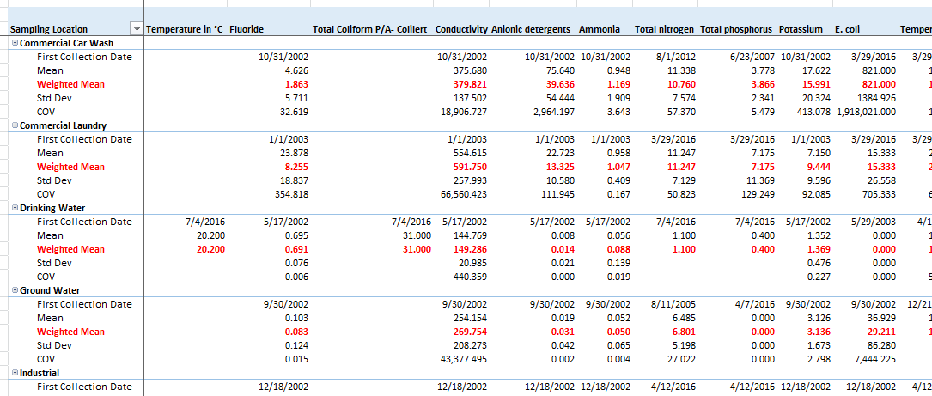

New data can be input into a separate tab that is integrated with the overall CFL. Depending on the illicit discharge source that was identified from the illicit discharge investigation (e.g. commercial washwater, residential laundry washwater, etc), the appropriate library from the drop down list is selected. Weights may be assigned and determined by the user – for example, Richmond’s library assigns the most weight to local data and less weight to regional or national data. In this iterative manner of updating the CFL with data, chemical signatures of known pollution sources is isolated along with their coefficient of variation.

https://eros.usgs.gov/aerial-photography
All thresholds should be established against a locally developed chemical fingerprint library.
Optical brightener thresholds are still being researched; their use in an IDDE program should be considered within the framework of an adaptive chemical fingerprint library.

